CBOE
Test Plan
PITS 58016
SEDL 9484
Class Setup
For the following test cases, you will need to verify that you are using a nickel class for both options and strategy. I would recommend a class with the description of ‘INDEX D’ for options and ‘INDEX D Spread’ for strategies.

Options

Strategies

Trading Property Setup
In addition to the normal COA action setup, the ‘Auction Minimum Price Increment’ will need to be set to ‘5’ for your strategy product you selected above.

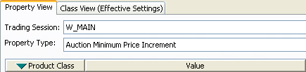

Test Case 1:

- MM1 enters quote 1 – 1.20 100 x 100 for Leg 1
- MM1 enters quote 0.5 – 0.7 100 x 100 for Leg 2
- MM1 enters CUST1 ‘C’ OPPST 10 @ 0.7
- MM1 enters CUST2 ‘C’ OPPST 10 @ MKT
  - Verify auction has started
- MM1 responds to auction ‘M’ SAME 10 @ -0.7

Verify CUST2 trades 10 with the Auction Response at 0.65. Verify the legs of the strategy are traded at 1.20 and 0.55.
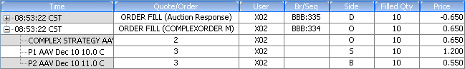

Test Case 2:

- MM1 enters quote 32.70 – 34.80 100 x 100 for Leg 1
- MM1 enters quote 28.00 – 30.10 100 x 100
- MM1 enters CUST1 ‘C’ SAME 10 @ -4.8
  - Verify auction has started
- MM1 responds to auction ‘M’ OPPST 10 @ 4.75

Verify CUST1 trades with Auction response @ -4.75 and that the legs are traded at 33.78 and 29.03 respectively
